 Overview: The Texas Margins Tax

Executive Summary
An August, 2008 report by the Bureau of Labor Statistics ranked Texas number one in the nation in new jobs created. While many states have slumped economically, and a financial crisis has gripped the nation, Texas has prospered by comparison. To ensure continued future growth, the Legislature should continue to review the current tax structure to look for opportunities for improvement, including changes to the margins tax.

This paper addresses why the 79th Legislature replaced the previous Texas franchise tax explains how the current margins tax works. The paper concludes that the Texas margins tax must be reformed and simplified to protect small businesses and to ensure that the burden on all businesses is as low as possible.

Two options are suggested:

- Retain the existing margins tax, but reduce its burden – especially on small businesses – by lowering the rate, exempting businesses with revenue below $1 million, and requiring a supermajority in the Legislature to raise the rate.
- Replace the margins tax with a franchise fee paid by all businesses in Texas.

The merits of each proposal are discussed in the sections that follow. Legislators should be able to use the information presented here to begin the process of improving Texas’ business tax climate.

How the New Margins Tax Works
The new margins tax was implemented by House Bill 3 during the Third Called Session of the 79th Legislature, in May 2006. The Tax was amended by House Bill 3928 during the 80th Legislature and is effective for any tax returns due on or after January 1, 2008.

The new margins tax replaced the Texas franchise tax, which was levied at a rate of 4.5 percent, but allowed many types of business – such as those organized as partnerships – to avoid paying the tax. The new margins tax is levied on gross receipts at a rate of 1 percent, although businesses primarily engaged in retail or wholesale are taxed at 0.5 percent. The tax applies to a broader range of businesses than the previous franchise tax, including corporations, limited liability companies, partnerships, business trusts, professional organizations, business associations, and joint ventures. Some legal entities, such as sole proprietorships, are still exempted from the new margins tax.

A business that is required to pay the new margins tax must calculate its “taxable margin,” which is the lesser of:

- Total revenue (gross receipts) minus the cost of goods sold; or
- Total revenue minus cost minus compensation (except contract labor costs); or
- Total revenue multiplied by 70 percent.

Businesses with total revenue of $300,000 or less are exempted from paying the tax, as are businesses that calculated their tax liability to be less than $1,000. Small businesses are eligible for deductions based on their total revenue:

- $300,001 to $399,999 = 80 percent deduction.
- $400,000 to $499,999 = 60 percent deduction.
- $500,000 to $699,999 = 40 percent deduction.
- $700,000 to $899,999 = 20 percent deduction.

Why the New Margins Tax Was Implemented

The new margins tax was implemented in order to raise the additional revenue that is necessary to fund reductions of school district property tax rates.

In its Neeley v. West Orange-Cove CISD decision (176 S.W. 3D 746 (TEX. 2005)), the Texas Supreme Court held that because independent school districts lacked “meaningful discretion” over property tax rates the “public school finance system violates Article VIII, section 1-e of the Texas Constitution.” Article VIII, section 1-e reads, “no State ad valorem taxes shall be levied upon any property within this State.”

In other words, although the Texas Constitution prohibits the imposition of a statewide property tax, because so many school districts were taxing at or near the $1.50 rate cap imposed by the Legislature, the Supreme Court declared that the school district property tax was, in effect, an unconstitutional statewide property tax. As a result of the Supreme Court’s 2005 decision, the Legislature had to reform the public education finance system to ensure that public schools could continue to receive funding after June 1, 2006.

The plan that the 79th Legislature implemented required school districts to lower their M&O tax rates such that the tax could no-longer be considered a statewide property tax. In order to fund the loss of revenue that school districts would suffer when they lowered their tax rates, the Legislature enacted the new margins tax, which will generate more revenue than the franchise tax it replaced, and reformed the motor vehicle sales and use tax and cigarette and tobacco taxes so that they will also generate increased revenue. All additional revenues generated by these reforms are dedicated to the Property Tax Relief Fund, and are directed to school districts to pay for property tax relief.

Problems Created by the New Margins Tax
Despite the Legislature’s best intentions, the new margins tax is not without flaws. The tax is complex, with businesses having a multitude of ways to calculate their liability, and unclear rules pertaining to what can be deducted from “total revenue” in calculating tax liability. While the Legislature’s goal of reducing property taxes was – and is – laudable, raising taxes on business is not the best solution. No tax, even when it is levied on a business, is truly paid by a business. All business taxes are paid by individuals. This is not a theory, it is a logical fact supported by the Texas Comptroller’s report to the Governor and 77th Texas Legislature:

It should be recognized that any tax levied directly on a business will ultimately be paid by real, live people – if not consumers via higher prices, then business owners via reduced profits or employees via reduced wages.

This point has been underlined recently by a range of studies, most notably the Tax Foundation’s 2006 State Business Tax Climate Index Background Paper, which concluded that:

Taxes affect business decisions, job creation and retention, plant location, competitiveness, and the long-term health of a state’s economy. Most importantly, taxes diminish profits. If taxes take a larger portion of profits, that cost is passed along to either consumers (through higher prices), workers (through lower wages or fewer jobs), or share-holders (through lower dividends or share value). Thus a state with lower tax costs will be more attractive to business investment.

Fundamentally, the franchise tax was revised in order to generate revenue to reduce school district property tax rates in response to a court ruling. Legislators must ensure that this property tax rate reduction is not achieved at the expense of job creation and growth in personal income.

It is also evident that gross margins taxation can be particularly damaging to businesses for which margins are already slight: a business could owe taxes even if it does not record a profit during the tax year.

The Business Tax Advisory Committee

The Business Tax Advisory Committee, which is made up of legislators and tax and business experts, issued its report to the Legislature on January 9, 2009. The committee’s report focused on how the new margins tax is working, with a particular emphasis on how it is affecting businesses in Texas.

The Business Tax Advisory Committee report revealed that the margins tax had collected $4.5 billion in revenue through the end of fiscal year 2008. The report noted specifically that the $4.5 billion collected “was about $1.4 billion below the official revenue estimate of $5.9 billion, but $1.4 billion above the amount of franchise taxes paid in fiscal 2007.”

However, the Business Tax Advisory Committee report cautions that:

[F]iscal 2008 year cash revenue may not necessarily offer an accurate reflection of actual first year tax liability. Many businesses—particularly large taxpayers—as is normal, did not file their reports until the following fiscal year in November. At that time they either made their complete tax payment or generated a refund if their calculated tax liability was less than their extension payment…Even so, transitional issues unique to the first year of the revised franchise tax on margin may have resulted in artificially lower tax collections, and 2008 report year returns may not be indicative of the ultimate size of the tax.

The report also suggests that in fiscal year 2008, the new margins tax is likely to have been subject to a unique and one-time occurrence of entities reorganizing themselves, which will have negatively impacted collections:

The statute preserved a portion of the tax base in the first year by providing for a cutoff date by which taxpayers would be allowed to change entities. For example, some partnerships in existence at the time the legislature passed the margin calculation may have effectively merged into other entities prior to June 30, 2007, removing a portion of their business activity from the first year of the prospective tax base. To the extent these partnerships have merged into taxable entities, the business activity will be fully taxable in subsequent years. This will be an area of evaluation for the committee’s next biennial report.

The report also discusses how the margins tax impacted different sectors of the state’s economy, noting that four sectors – mining, rail transportation, agriculture, and wholesale trade – experienced sector-wide decreases in franchise tax (2007) to margins tax (2008) liability. Most sectors, however, experienced an increased liability; notably telecommunications, waste management, arts, entertainment and recreation, and health services, each of which experienced sector-wide doubling of tax liability from 2007 t0 2008.

Reforming the Margins Tax

The Business Tax Advisory Committee’s assertion that Texas businesses pay a higher percentage of taxes than their competitors in other states demands that, at minimum, the negative impact of tax be eased so that Texas retains its status as the leading business state in the nation. However, legislators should also consider significantly reforming the margins tax and, if necessary, its elimination.

Easing the Burden
To ease the negative impact of the margins tax, at minimum, the 81st Legislature must ensure that the following reforms are enacted:
- Cut the rates at which the tax is levied.
- Require a two-thirds vote in the Legislature before the tax rate can be increased.
- Raise the small business exemption to $1 million in total revenue.

These reforms will provide immediate tax relief to all tax businesses that pay the margins tax. They will also protect Texas business climate against future increases in margins tax rates, and will establish a significant exemption to protect small businesses.

Alternatives to the Margins Tax

Despite these opportunities to reform the margins tax, a better alternative might be to eliminate the tax as it currently exists, and replace it with a fairer, less complex alternative that draws revenue from a broader base. The TCC Margins Tax Study Group discussed one idea in particular:
A fee paid by every businesses registered in Texas: Expanding the base will allow all businesses to pay a small fee, and will reduce the burden on the businesses that currently remit the margins tax.

Small Fee on Every Business Registered in Texas
According to the Business Tax Advisory Committee, the franchise tax that preceded the margins tax had a base of 696,894 taxpaying entities. In short, these taxpaying entities were for-profit corporations and limited liability companies (LLCs). Limited partnerships (LPs), sole proprietorships, and non-corporate associations were not subject to the tax. The margins tax expanded the franchise tax base to include other entities, but continued to exempt sole proprietorships, general partnerships, and some other types of business.
As a result of the large number of businesses in Texas that are still not required to pay the margins tax, simply requiring every business to pay a small fee – instead of the margins tax – would be one of the simplest ways to raise the revenue that would have been generated by the previous franchise tax as well as revenue for property tax relief.
The Internal Revenue Service reports that in 2007, 652,157 businesses located in Texas filed federal tax returns, which is roughly similar to the number of businesses that were required to pay the previous franchise tax. However, the Office of the Texas Secretary of State reports that there are 2,487,889 corporations, limited liability companies, and limited partnerships currently registered in Texas; of these 955,573 are listed as “active.”
The table below gives an indication of the size of fee that could be used to replace the margins tax, depending on the range of entities that are required to pay (the table assumes a revenue target of $6 billion):

AVERAGE FRANCHISE FEE REQUIRED (ADJUSTED FOR SIZE OF TAX BASE)
$6 billion revenue target | Number of Entities | Average Fee per Entity
Entities filing returns with Internal Revenue Service (FY2007)* | 652,157 | $9,200
Entities subject to previous franchise tax⁺ | 696,894 | $8,610
Entities subject to margins tax (FY 2008) ⁺ | 953,346 | $6,294
“Active” entities registered with Secretary of State (FY2007)# | 1,042,596 | $5,755
Individual IRS returns with business or professional income, plus all other business entities filing IRS returns (FY2008) ¥ | 2,593,612 | $2,310
All entities registered with Secretary of State (FY2007)# | 2,694,661 | $2,227
Comptroller estimate of active entities in Texas | 2,996,655 | $2,002
¥TCC Information Request to Internal Revenue Service (2008 estimates).
* Internal Revenue Service, Number of Returns Filed, by Type of Return and State, Fiscal 2007.
⁺Highlights of the Draft Proposal, Business Tax Advisory Committee Report.
#TCC Information Request to the Office of the Secretary of State.

It is clear from the table that the size of the fee would be significantly impacted by the number of entities to which the fee is applied. Smaller businesses could be protected from a large fee by imposing a sliding fee scale based on the size of a business.

The example below outlines how a sliding fee scale could work; the fee scale shown uses gross receipts to determine the size of the fee that a business is required to pay. The fee scale is based on the 696,894 entities that were subject to the previous franchise tax, which is the minimum number of entities that could be expected to have to pay a franchise fee.

EXAMPLE: FRANCHISE FEE SCALE (1)
Fee Band | Business Revenue  ($ million) | Annual Franchise Fee | Number of Businesses* | Revenue to the State  ($ million) | Maximum Effective Tax Rate
A | $0 - $0.49 million | $ 550 | 523,276 | $ 287.8 million | n/a
B | $0.5 - $0.99 million | $ 1,250 | 46,561 | $ 58.2 million | 0.25%
C | $1 – $9.99 million | $ 2,500 | 85,126 | $ 212.8 million | 0.25%
D | $10 - $49.99 million | $ 25,000 | 24,099 | $ 602.5 million | 0.25%
E | $50 - $99.99 million | $ 125,000 | 6,392 | $ 799.0 million | 0.25%
F | $100 - $249.99 million | $ 250,000 | 5,491 | $ 1,372.8 million | 0.25%
G | $250 million + | $ 450,000 | 5,949 | $ 2,677.1 million | 0.18%
 |  | TOTAL: | 696,894 | $ 6,001.2 million
*The number of businesses in each fee band is based on data provided by the Business Tax Advisory Committee.
Note: The Franchise Fee Scale outlined above is simply an illustration of how such a fee could work. Three more iterations of a franchise fee are developed later in this document; all of which are intended for discussion and are not final suggestions of the Margins Tax Study Group.

One of the most important aspects of the fee scale is the maximum effective tax shown in the far right column. The maximum effective tax rate is based on the franchise fee for the lowest revenue-generating business in each fee band: A business in fee band D with revenue of $10 million would pay a $25,000 fee, which is 0.25 percent of its revenue. Similarly, a business in fee band F with revenue of $100 million would pay a $250,000 fee, which is 0.25 percent of its revenue.

However, as the revenue of a business grows, the effective tax rate will fall until the business moves up into the next fee band. For example, a business at the high end of band D, earning revenue of $49 million, would pay a $25,000 fee which represents just 0.05 percent of its total revenue.

The maximum effective tax rate is 0.25 percent for every fee band, except A and G. This is significant because it is lower than the current margins tax rates of 1 percent and 0.5 percent. While the margins tax allows for deductions from gross revenue that the franchise fee would not allow, the lower effective rate of the fee ensures tax relief for most businesses.

Benefits of a Franchise Fee

- Expanded Tax Base

Unlike the current margins tax and the previous franchise tax, the franchise fee would be paid by all entities doing business in Texas. As discussed above, many types of business including limited partnerships, sole proprietorships, and non-corporate associations were not subject to the previous franchise tax. Similarly, the new margins tax exempts, among others, sole proprietorships and general partnerships.

Analyzing the new margins tax in March 2008, the House Research Organization wrote that:

After liability protection was extended to partnerships in the 1980s, many businesses reorganized to avoid the corporate franchise tax. These businesses contributed nothing to franchise tax revenues, while benefiting from the state’s educational system and other services. The business margins tax corrects this disparity by covering service-sector businesses more effectively. Texas has a growing population with expanding needs, and the business margins tax establishes a more stable revenue source.

However, despite attempts to broaden the base, the statistics above demonstrate that the new margins tax base (516,457) may in fact be smaller than the previous franchise tax base (696,894). Moreover, there are 955,573 “active” business entities registered with the Texas Secretary of State (SOS), and about 2.5 million total business entities in the state, according to the Internal Revenue Service.

Any franchise fee should attempt to bring in as many of these business entities as possible. As the chart on page 5 shows, bringing in all 2.5 million business entities would reduce the average fee per business to around $2,300, while even if just the 955,573 “active” businesses registered with SOS were brought in, the average fee would be $6,280, as compared to $11,620 for the current margins tax base.

Bringing as many payers as possible into the system is a hallmark of tax fairness. It is important to remember that the margins tax was created to fund public education by providing school district property tax relief as required by the Texas Supreme Court.

Because the franchise fee can be applied at a very low level – a minimum amount of $550 per business in the example above – every business can be expected to contribute. This would meet one of the key characteristics of tax fairness: Testifying before the U.S. House Committee on Ways and Means, William W. Beach of the Heritage Foundation pointed out that “I think we all can agree that “tax fairness” at least means that everyone pays their fair share.”

Similarly, a national Rasmussen survey published in July 2008 revealed that 43 percent of Americans favor a tax system in which “everyone pays their fair share”, while 50 percent favor a system that “helps the economy grow.” Both of these goals can be achieved through the franchise fee.

- Encouraging Growth

When reforming the margins tax, legislators must be mindful of the effect that the state’s business tax structure can have on economic growth and competitiveness. The Tax Foundation underscored this point in its 2009 State Business Tax Climate Index:

Anecdotes about the impact of state tax systems on business investment are plentiful. In Illinois, hundreds of millions of dollars of capital expenditures were delayed when Governor Blagojevich proposed a hefty gross receipts tax. Only when the legislature resoundingly defeated the bill did the investment resume. In 2005, Intel decided to build a multi-billion dollar chip-making facility in Arizona due to its favorable corporate income tax system. California struggles to retain businesses within its borders because Nevada provides a low-tax alternative. Anecdotes such as these reinforce what we know from economic theory: taxes matter to businesses, and those places with the most competitive tax systems will reap the benefits of business-friendly tax climates.

The Tax Foundation goes on to describe the characteristics of a sound state tax system that will encourage economic growth:

Good state tax systems levy low, flat rates on the broadest bases possible, and they treat all taxpayers the same. Variation in the tax treatment of different industries favors one economic activity or decision over another. The more riddled a tax system is with politically motivated preferences the less likely it is that business decisions will be made in response to market forces.

Based on this analysis, it is clear that a franchise fee would be a significant improvement on the Texas margins tax. As a result of low rates and broad base, a franchise fee would encourage economic growth. Regardless of industry, every business would be treated the same, and while large businesses would have to pay a larger fee than small businesses, the fee would always be at a low rate.

In a critique of gross receipts taxation (similar to the Texas margins tax), the Council on State Taxation (COST) wrote that “a tax that violates fundamental principles of tax policy, like gross receipts taxes, directly impacts average people by frustrating job creation and economic development.”

It is clear from COST’s analysis that a franchise fee would overcome many of the problems associated with the Texas margins tax:

An economically neutral tax does not influence business choices (of location, of operational entity, of suppliers etc.). Gross receipts taxes are among the least neutral of all taxes. Because a gross receipts tax is imposed every time a product is sold, it discriminates against producers that are not vertically integrated.

The franchise fee would better meet the economic neutrality test because it would be far less likely to adversely affect business decisions such as location and entity type. The fee would be low enough to encourage businesses to locate in Texas and because every type of business would be required to pay, there would be no incentive for a company to organize itself to avoid paying the fee. Similarly, the fee would only be levied once a year, so the pyramiding effect that results from levying the margins tax each time a product is sold would be almost entirely eliminated.

- Low Compliance Cost

For a tax to be fair, it is important that the tax have low compliance costs. That is, the cost to a business of calculating and remitting its tax liability must not represent a significant financial burden. A 2006 article in the Journal on State Taxation discussing the Texas margins tax asserted that:

At first blush, the [Texas margins tax] represents another attempt by states to expand the tax base. However, in fact, this attempt at “simplification” of tax administration represents another step in the increasingly complex patchwork of tax compliance that faces corporate America.

In contrast to the margins tax – and even the previous franchise tax – the franchise fee would have virtually zero compliance costs. A business would simply have to indicate the revenue band it falls into and then remit the flat fee associated with that rate band. There would be no complex calculation of tax liability involving deductions from revenue, such as cost of goods sold. The fee would be clear, transparent, and straightforward to calculate.

It is also worth noting that many businesses already have to pay various flat fees to the state, such as license fees and registration fees. A low fee of this nature does not appear to inhibit business activity. For instance, the Legislative Budget Board reports that barbers can be required to pay license fees up to $1,000 per year, cosmetology licenses cost $500 per year, and auctioneer licenses cost $50 per year.

Franchise Fee Case Studies

The examples that follow illustrate the impact of a franchise fee on businesses operating in Texas.

1) Hypothetical Business with Five Percent Annual Revenue Growth

The first business is a hypothetical company that starts with $300,000 annual revenue and grows at a rate of five percent per year over a thirty year period (2010 – 2040). This revenue growth and the company’s franchise fee liability are both shown in the chart that follows. The company begins in Fee Band A ($550), moves into Band B ($1,250), and ends in Band C ($2,500):

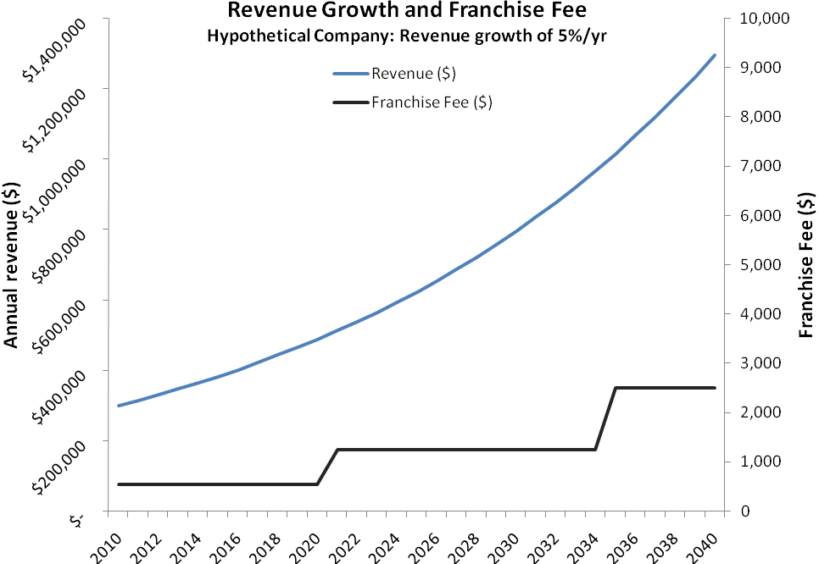

The chart shows some of the primary strengths of the franchise fee approach: The fee is low, relative to annual revenues, and the fee is predictable, which gives the company certainty about its liability. For a small but growing company, such as the one used in this example, the franchise fee will remain flat for several years at a time even as the company’s revenue grows. It is only when a business moves into a higher fee band that its fee will increase. However, the increased fee is predictable, does not have higher compliance costs than a lower fee, and will remain flat for as long as the company is in the new fee band.

The next chart emphasizes the low effective rate of the franchise fee. Each time the revenue of the hypothetical company pushes into a new fee band, the effective tax rate rises close to the 0.25 percent maximum. However, as the business continues to grow, the effective tax rate declines because the flat fee remains the same as long as the business is in the same fee band.

This “flat fee” approach encourages businesses to grow because it allows for significant revenue growth without incurring any tax penalty. The franchise fee would bring many of the benefits of flat rate taxation to Texas’ business environment. In 2005, the Heritage Foundation argued that flat rate taxation encourages growth by “reducing penalties against productive behavior, such as work, risk taking, and entrepreneurship.”

While it must be pointed out that the franchise fee would not be set at a flat rate, the fee still exhibits many of the benefits of flat rate taxation because of its low effective rate that declines as a business grows within each fee band. This effect is illustrated below:

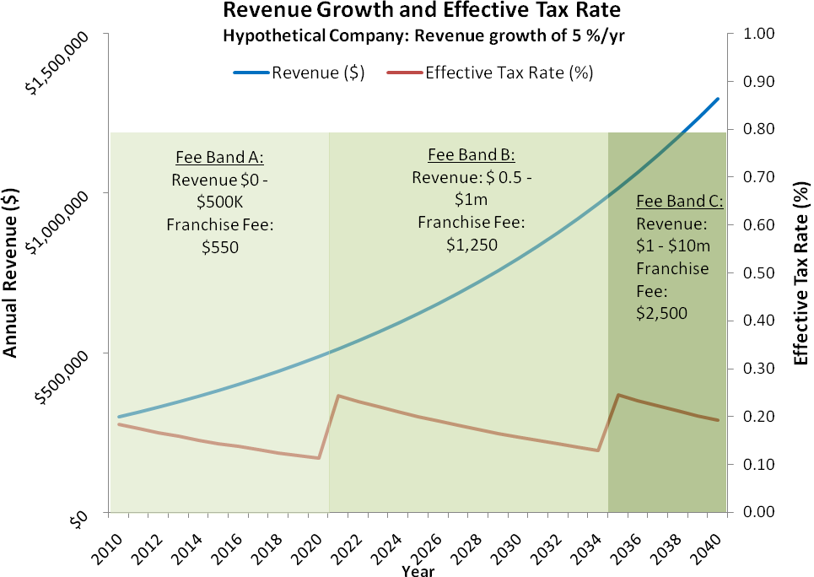
As the hypothetical company grows its revenue at the rate of 5 percent per year, the effective tax rate rises only when the company moves into a new fee band, for every other year of growth, the effective tax rate declines. The tax rate also remains extremely low even when the company enters a new fee band.

2) Wisenbaker Building Services Inc.
Wisenbaker Builder Services is a privately-owned company based in Houston, that was founded in 1970. Today, the company has annual revenues of almost $150 million and is subject to the margins tax. Under the previous franchise tax, Wisenbaker had a tax liability of $296,745 in fiscal 2007. However, the company’s margins tax liability in fiscal 2007 would have been $491,276, an increase of 66 percent. The chart below tracks Wisenbaker’s actual annual revenue between 1986 and 2007 together with the fee that the company would have had to pay if the franchise fee had been in effect:
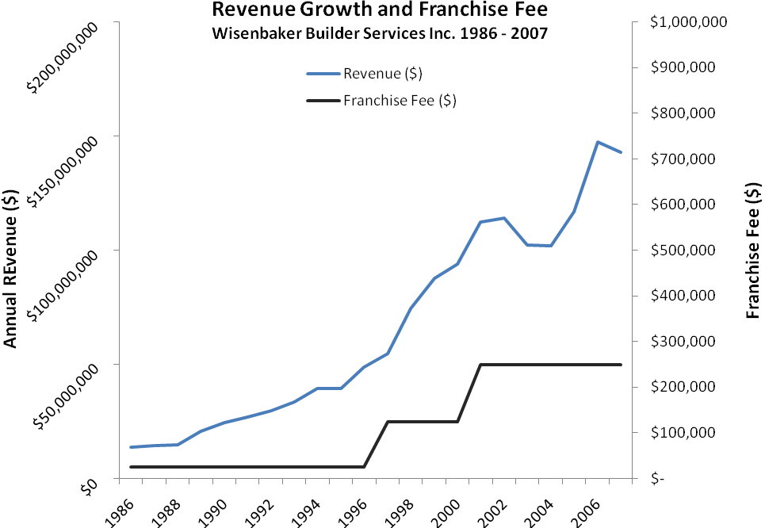
The chart clearly shows a very similar progression in the franchise fee liability to that of the hypothetical company discussed above. The fee remains flat for many years at a time, and begins to move up incrementally as Wisenbaker’s revenue growth accelerated between 1996 and 2002. It is important to note that although Wisenbaker’s revenue dropped between 2002 and 2005, the franchise fee remained at $250,000 because the company did not drop into a lower fee band.
The impact of this on the effective tax rate is shown in the following chart. With the franchise fee in effect, Wisenbaker’s effective tax rate would have continually declined between 1986 and 1996, even as the company’s revenue almost quadrupled from $13.7 million to $48.8 million. Rapid revenue growth ($54.6 million to $112.5 million) between 1997 to 2001 would also have resulted in a rapid decline in the effective tax rate.
The revenue decline that Wisenbaker encountered between 2002 and 2005 would have resulted in a slight rise in the effective tax rate. This can be observed in the far right section of the chart:
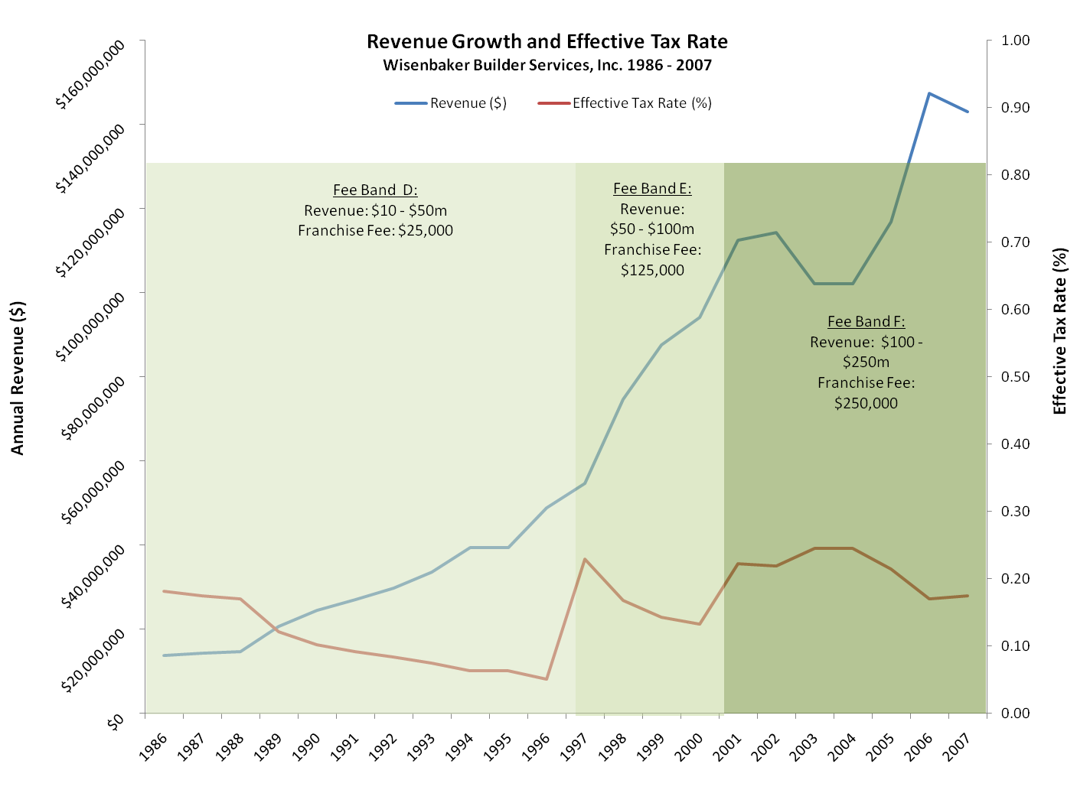
However, even with this declining revenue, the effective tax rate would have remained below 0.25 percent of total revenue – much lower than the 1 percent rate of the margins tax.

3) Range Resources Inc.

Range Resources Inc. is a publicly-traded oil and gas company based in Fort Worth. Today, the company has annual revenues approaching $1 billion, but as recently as 1998, revenues were just in excess of $100 million.

This rapid revenue increase can be clearly seen on the chart below. The charts that follow illustrate Range Resource’s revenue growth between 1998 and 2007, during which time the company would have moved from fee band F ($250,000) to fee band G ($450,000) had the franchise fee been in place.
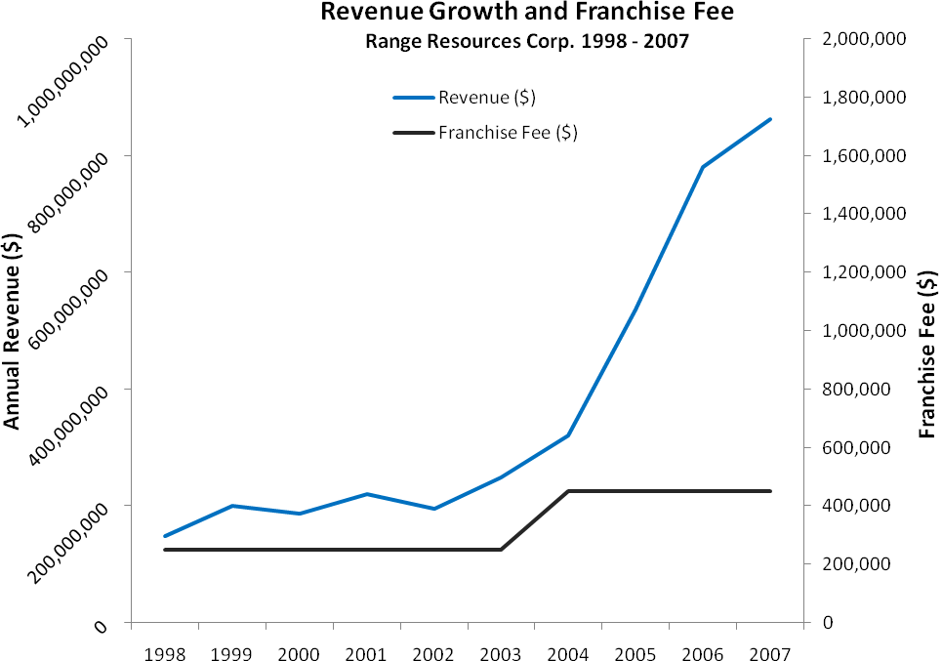
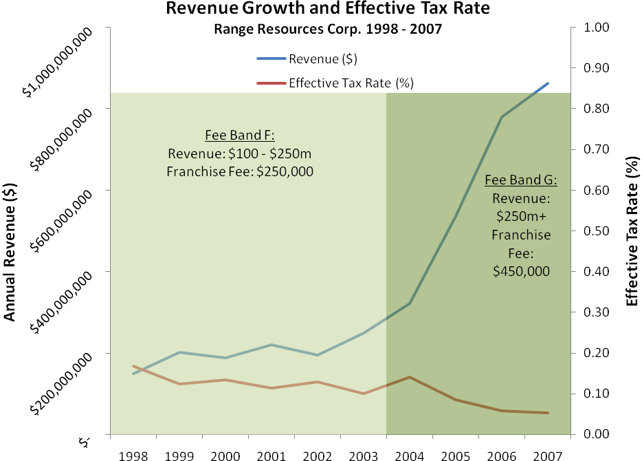
The charts clearly illustrate the low tax burden that a company like Range Resources would have experienced had the franchise fee been in place for the last decade. As the company’s revenue grew, their tax liability would have remained low and predictable. It is especially noteworthy that in the period since 2004, when Range Resources’ revenue began to increase significantly (partly as a result of the development of the Barnett Shale), the company’s effective tax rate would have declined rapidly.
Because the effective rate of the franchise fee declines during periods of revenue growth, the fee rewards successful businesses: In 2007, Range Resources created 146 new jobs as the company continued to expand. However, the company’s gross margin (from its nationwide activities) increased from $534 million in 2006 to $786 million in 2007. The increased gross margin attributable to activities in Texas would have resulted in a significant increase in the company’s franchise/margins tax liability, and would therefore have penalized improved performance and growth. The franchise fee approach would have rewarded growth and served as an incentive for improved economic performance and job creation.

Other Franchise Fee Options
The franchise fee outlined above is just one of many ways in which a fee scale could be designed. Legislators must consider a range of factors that will determine what type of fee scale would be most appropriate for Texas businesses. These factors include:
- How simple or complex a franchise fee should be (i.e. how many different fee bands should be included).
- The total amount of revenue that the franchise fee should generate.
- The types of businesses that should be subject to the franchise fee (and hence the number of the businesses that would have to pay the fee).
- The effective rate at which the fee would be levied.
To illustrate this point, it is worth demonstrating how an alternate franchise fee could work. This version of the franchise fee uses a different assumption about the number of businesses that should be subject to the fee, and employs a much larger number of fee bands than the version explained above.
This franchise fee is based on the number of business entities in Texas that filed IRS returns in FY 2008, plus individual IRS returns with business or professional income, which brings a total of 2,593,492 payers to the table (the second to last category in the table on page 5). Additionally, instead of employing seven fee bands ranging from $550 to $450,000, this franchise fee option employs twenty fee bands, ranging from $100 to $1,000,000.

While the larger number of fee bands makes this version of the franchise fee slightly more complex, it also allows for much lower fees to be charged to businesses with revenues below $1 million and for higher fees to be charged to businesses with revenue over $250 million:

EXAMPLE: FRANCHISE FEE SCALE (2)
Fee Band | Business Revenue | Annual Franchise Fee | Number of Businesses* | Revenue to the State  ($ million) | Maximum Effective Tax Rate
A | $0 - $24,999 | $ 100 | 2,176,671 | $ 217.667 million | n/a
B | $25,000 - $99,999 | $ 200 | 139,976 | $ 27.995 million | 0.80%
C | $100,000 - $249,999 | $ 350 | 69,988 | $ 24.496 million | 0.35%
D | $250,000 - $499,999 | $ 500 | 33,359 | $ 16.679 million | 0.20%
E | $500,000 - $999,999 | $ 1,500 | 46,561 | $ 69.842 million | 0.30%
F | $1 m- $2.49m | $ 2,500 | 46,043 | $ 115.108 million | 0.25%
G | $2.5m - $4.99m | $ 3,500 | 22,678 | $ 79.373 million | 0.14%
H | $5m - $9.99m | $ 10,000 | 16,405 | $ 164.050 million | 0.20%
I | $10m - $14.99m | $ 25,000 | 13,797 | $ 344.917 million | 0.25%
J | $15m - $24.99m | $ 50,000 | 6,868 | $ 343.411 million | 0.33%
K | $25m - $49.99m | $ 100,000 | 3,434 | $ 343.411 million | 0.40%
L | $50m - $74.99m | $ 150,000 | 6,392 | $ 958.800 million | 0.30%
M | $75m - $124.99m | $ 200,000 | 3,144 | $ 628.720 million | 0.27%
N | $125m - $174.99m | $ 250,000 | 1,565 | $ 391.234 million | 0.20%
O | $175m - $249.99m | $ 300,000 | 782 | $ 234.740 million | 0.17%
P | $250m - $349.99m | $ 350,000 | 3,093 | $ 1,082.718 million | 0.14%
Q | $350m - $499.99m | $ 500,000 | 1,428 | $ 713.830 million | 0.14%
R | $500m - $749.99m | $ 650,000 | 773 | $ 502.691 million | 0.13%
S | $750m - $999.99m | $ 800,000 | 357 | $ 285.552 million | 0.11%
T | $1 billion + | $1,000,000 | 178 | $ 178.000 million | 0.10%
 |  | TOTAL: | 2,593,493 | $ 6,723.702 million
*The number of businesses in each fee band is an estimate based data provided by the Business Tax Advisory Committee (BTAC). It was assumed that there were fewer businesses at the high revenue end of each BTAC fee band and therefore the fee bands in this chart were adjusted accordingly.
In addition to being a broader fee scale, the example above also uses a larger tax base than the example discussed earlier. The chart assumes that every business entity included in this version of the fee scale that was not included in the previous version is a small business with revenue below $25,000 per year; this is why the vast majority of businesses (2,176,671) fall into fee band A. Despite this, the fee scale still generates $6.7 billion of revenue for the state, a figure which would be higher if it turns out – as is highly likely – that some of these new businesses actually have revenues above $25,000.
A further alternative fee scale follows. This fee scale exempts businesses with revenues below $500,000 per year, and imposes higher fees on businesses in upper fee bands so that the maximum effective tax rate is 0.25 percent in each of the fee bands F through T:
EXAMPLE: FRANCHISE FEE SCALE (3)
Fee Band | Business Revenue | Annual Franchise Fee | Number of Businesses* | Revenue to the State  ($ million) | Maximum Effective Tax Rate
A | $0 - $24,999 | $ - | 2,176,671 | $ - | n/a
B | $25,000 - $99,999 | $ - | 139,976 | $ - | n/a
C | $100,000 - $249,999 | $ - | 69,988 | $ - | n/a
D | $250,000 - $499,999 | $ - | 33,359 | $ - | n/a
E | $500,000 - $999,999 | $ 1,250 | 46,561 | $ 58.202 million | 0.25%
F | $1 m- $2.49m | $ 2,500 | 46,043 | $ 115.108 million | 0.25%
G | $2.5m - $4.99m | $ 6,200 | 22,678 | $ 140.603 million | 0.25%
H | $5m - $9.99m | $ 12,500 | 16,405 | $ 205.063 million | 0.25%
I | $10m - $14.99m | $ 25,000 | 13,797 | $ 344.917 million | 0.25%
J | $15m - $24.99m | $ 37,500 | 6,868 | $ 257.558 million | 0.25%
K | $25m - $49.99m | $ 62,500 | 3,434 | $ 214.632 million | 0.25%
L | $50m - $74.99m | $ 125,000 | 6,392 | $ 799.000 million | 0.25%
M | $75m - $124.99m | $ 185,000 | 3,144 | $ 581.566 million | 0.25%
N | $125m - $174.99m | $ 310,000 | 1,565 | $ 485.130 million | 0.25%
O | $175m - $249.99m | $ 440,000 | 782 | $ 344.286 million | 0.25%
P | $250m - $349.99m | $ 625,000 | 3,093 | $ 1,933.425 million | 0.25%
Q | $350m - $499.99m | $ 875,000 | 1,428 | $ 1,249.203 million | 0.25%
R | $500m - $749.99m | $ 1,250,000 | 773 | $ 966.713 million | 0.25%
S | $750m - $999.99m | $ 1,900,000 | 357 | $ 678.186 million | 0.25%
T | $1 billion + | $ 2,500,000 | 178 | $ 446.175 million | 0.25%
 |  | TOTAL: | 2,593,493 | $ 8,819.763 million
*The number of businesses in each fee band is an estimate based data provided by the Business Tax Advisory Committee (BTAC). It was assumed that there were fewer businesses at the high revenue end of each BTAC fee band and therefore the fee bands in this chart were adjusted accordingly.

The final version of the franchise fee scale (4) is presented below. The scale is based on an estimate of the number of businesses in Texas and their revenues provided to the Texas Conservative Coalition by the Comptroller of Public Accounts in December 2008. The fee scale exempts all businesses with revenue below $100,000 from paying any fee.

This version of the fee scale is notable for the large number of entities it captures, which allows the maximum effective tax rate to be kept at a very low level: 0.10 percent for businesses with revenue from $100,000 to $1,000,000, and 0.11 percent for businesses with revenue above $1,000,000.

EXAMPLE: FRANCHISE FEE SCALE (4)
Fee  Band | Revenue | Number of Businesses | Fee | Revenue | Maximum  Effective Rate
A | Under $25,000 | 1,716,859 | - | - | n/a
B | $25,000 - $99,999.99 | 600,640 | - | - | n/a
C | $100,000 - $249,999.99 | 280,613 | $ 100.00 | $ 28,061,300.00 | 0.10%
D | $250,000 - $499,999.99 | 146,236 | $ 250.00 | $ 36,599,000.00 | 0.10%
E | $500,000 - $999,999.99 | 103,773 | $ 500.00 | $ 51,866,500.00 | 0.10%
F | $1,000,000 - $2,499,999.99 | 75,517 | $ 1,100.00 | $ 83,068,700.00 | 0.11%
G | $2,500,000 - $4,999,999.99 | 28,945 | $ 2,750.00 | $ 79,598,750.00 | 0.11%
H | $5,000,000 - $9,999,999.99 | 15,539 | $ 5,500.00 | $ 85,464,500.00 | 0.11%
I | $10,000,000 - $49,999,999.99 | 13,959 | $ 11,000.00 | $ 153,549,000.00 | 0.11%
J | $50,000,000 - $99,999,999.99 | 5,606 | $ 55,000.00 | $ 308,330,000.00 | 0.11%
K | $100,000,000 - $249,999,999.99 | 4,414 | $ 110,000.00 | $ 485,540,000.00 | 0.11%
L | $250,000,000 - $999,999,999.99 | 3,056 | $ 275,000.00 | $ 840,400,000.00 | 0.11%
M | $1,000,000,000 - $4,999,999,999.99 | 1,170 | $ 1,100,000.00 | $ 1,287,000,000.00 | 0.11%
N | $5,000,000,000 - $9,999,999,999.99 | 160 | $ 5,500,000.00 | $ 880,000,000.00 | 0.11%
O | $10,000,000,000 + | 168 | $ 11,000,000.00 | $ 1,848,000,000.00 | 0.11%
 | TOTAL: | 2,996,655 |  | $6,167,457,750.00
Note: Franchise fee scale (4) is based on business revenue information provided by the Comptroller of Public Accounts in response to a request by the Texas Conservative Coalition. The revenue figures provided are “everywhere” receipts, an updated fee scale will be provided when the figures for Texas receipts are received; the franchise fee should only be based on the Texas receipts of a business entity.

The Path Forward
This paper has presented a franchise fee as an alternative to the Texas margins tax that was implemented by the 79th Legislature. The paper includes four examples of how the franchise fee could work, each with a different tax base and fee structure.
These examples are not set in stone, and legislators should determine a version of the franchise fee that will impose the lowest possible burden on each business that is captured by the fee. This will require continued interaction with businesses that would be impacted by the fee, as well as other stakeholders and elected officials to ensure that any proposal is an improvement on the current margins tax. Texas’ strong business climate must be maintained, a point which has been underscored by the Federal Reserve Bank of Dallas:
It’s hard to challenge the general finding that the Texas business climate has been widely regarded as above average.
And this business climate has helped Texas compete globally. Recent Southwest Economy articles have documented how Texas is increasingly open to the global economy and how its growth rate has exceeded the nation’s. Both measures are consistent with a favorable business climate.
Today’s globalizing, technology-rich economy allows factors of production to move faster and farther in seeking places where they can be used most effectively. In this environment, it makes sense that states like Texas with relatively favorable business climates would see their economies—and populations—grow faster than in the U.S. overall.
As the national and global economies continue on a downward trend, it is more important than ever for Texas to retain its competitive edge.

ENDNOTES

Texas Comptroller’s Report to the Governor and 77th Texas Legislature, January 2001; http://www.window.state.tx.us/taxinfo/incidence/nature.html
Tax Foundation, Background Paper: State Business Tax Climate Index 2006, http://www.taxfoundation.org/files/bp51.pdf
The Business Tax Advisory Committee, Report to the 81st Legislature, January 2009.
Ibid.
Ibid.
House Research Organization, Bill Analysis, House Bill 3 (79S3), April 24, 2006.
Ibid.
Internal Revenue Service, Number of Returns Filed, by Type of Return and State, Fiscal 2007.
In its 2008-09 Certification of Revenue Estimate, the Office of the Comptroller estimated that the margins tax would generate $11.9 billion over the 2008-09 biennium, or almost $6 billion per year.
House Research Organization, “Business margins tax implementation begins,” Interim News #80-4, March 27, 2008.
“Measuring the Fairness of a Tax System,” William W. Beach, Testimony before United States House of Representatives Committee on Ways and Means, June 8, 2008; http://www.heritage.org/Research/Taxes/tst060805a.cfm
National Survey of 1,000 Likely Voters, Rasmussen Reports, July 25, 2008.
The Tax Foundation, 2009 State Business State Climate Index, Background Paper No. 58, October, 2008.
Ibid.
“Gross Receipts Taxes: Policy Position,” Council On State Taxation; http://www.statetax.org/uploadedFiles/About_COST/Policy_Statement/GrossReceiptsTaxes.pdf
Ibid.
“Texas’ New Margins Tax,” Giles Sutton, Jamie Yesnowitz, Pat O’Shea, John LaBorde and Doug Maziur, Journal of State Taxation, September – October 2006.
Legislative Budget Board, Revenue Survey, 2007.
“A Brief Guide to the Flat Tax,” The Heritage Foundation, Backgrounder #1866, July 7, 2005.
Morningstar Investment Research, Range Resources Inc. (NYSE:RRC), Financial Statements, 1998– 2007.
Range Resources Inc. 2007 Annual Report.
“Will New Business Tax Dull Texas’ Competitive Edge?” Southwest Economy, Issue 2, March/April 2008.

